
A Study on Visual Merchandising and Its Impact on Consumer Purchasing Behavior
Name: Shivam Ghanshyam Gupta Roll No. 82
Bachelor of Commerce in Management Studies SEM III
GROUP MEMBERS Name: Shivam Gupta, Gopi Das, Dhruv Naik, Mirza Arsalan

GROUP MEMBERS ROLL NO: 82, 79, 94, 96
Under the Guidance Of Mr.Virupanagouda Asst.Professor



CERTIFICATE
I hereby certify that Mr. Shivam Ghanshyam Gupta, Student of M V Mandali’s
College of Commerce and Science studying in SYBMS program has completed a
C.E Project A Study on Visual Merchandising and Its Impact on Consumer Purchasing Behavior in the area of the best of my knowledge the work of the student is original and the information included in the project is correct

Internal Guide Head of the Department Principal

Declaration

I, Mr. Shivam Ghanshyam Gupta, Student of M V Mandali’s College of Commerce and Science studying in SYBMS program, hereby declare that I have completed the Community Engagement Project A Study on Visual Merchandising and Its Impact on Consumer Purchasing Behavior during the academic year 2025-2026.

The report is original, and the information/data included in the report is true emerging from the primary and/ secondary data gathered and analyzed as part of this Community Engagement project.

Due credit is extended on the work of Literature/Secondary Survey by endorsing it in the Bibliography as per prescribed format.

Signature of the Student with date Name of Student: Shivam Gupta

ACKNOWLEDGEMENT
I would like to express my profound gratitude to everyone who supported and guided me throughout the completion of this project.
First and foremost, I extend my sincere thanks to the Principal of MVM College of Commerce, Andheri West, and the Head of the Commerce Department for providing me with the opportunity to undertake this enriching project.
I am deeply indebted to my project guide, Prof. Mr.Virupanagouda , for his invaluable guidance, constant encouragement, and insightful feedback, which were instrumental in shaping this research.
My sincere appreciation goes to the management and staff of the retail stores who allowed me to conduct my observations. I am also thankful to all the respondents who generously participated in my survey; without their input, this study would not have been possible.
I wish to thank the college library staff for providing access to essential resources and literature.
Finally, I owe a special debt of gratitude to my family and friends for their unwavering support, patience, and motivation throughout this endeavor.
Shivam Ghanshyam Gupta

A STUDY ON VISUAL MERCHANDISING AND ITS IMPACT ON CUSTOMER BEHAVIOR IN RETAIL STORES

INDEX

Chapter No. | Title | Page No.
- | Cover Page | 0
- | Appendix | 1 - 4
- | Index | 5
1 | Introduction | 6 - 8
2 | Objectives of the Study | 9 - 10
3 | Review of Literature | 11 - 13
4 | Research Methodology | 14 - 23
5 | Data Analysis & Interpretation | 24 - 39
6 | Findings | 40 - 42
7 | Conclusion | 43 - 45
8 | Suggestions | 46 - 52
9 | References / Bibliography | 53 - 56

CHAPTER 1: INTRODUCTION

  - Background of the Study
In today's competitive retail landscape, visual merchandising has emerged as a critical factor in attracting customers, influencing purchasing decisions, and creating memorable shopping experiences. Visual merchandising encompasses all visual elements used in retail spaces to present products in their best light and create an appealing environment that encourages purchases.
The retail industry faces constant pressure to differentiate itself in an era where consumers have unlimited choices both online and offline. Physical stores must leverage visual merchandising strategies to compete effectively with e-commerce platforms by offering experiences that cannot be replicated online—the ability to see, touch, and interact with products in thoughtfully designed spaces.
Visual merchandising is not merely about aesthetic appeal; it is a strategic business tool that impacts customer behavior at multiple touchpoints—from attracting passersby to enter the store, guiding them through the space, highlighting key products, and ultimately influencing purchase decisions. Understanding how customers respond to various visual elements can help retailers optimize their store layouts, product displays, and overall shopping environment.

Significance of the Study
This study is significant for several reasons:
For Retail Businesses: The findings provide actionable insights into customer preferences and behaviors, enabling retailers to make data-driven decisions about store design, product placement, and visual merchandising investments.
For Marketing Professionals: Understanding the connection between visual elements and customer behavior helps in developing more effective in-store marketing strategies and promotional campaigns.

For Academic Research: This study contributes to the growing body of knowledge on retail consumer behavior and visual merchandising effectiveness in the Indian retail context.
For Customer Experience: By identifying pain points and preferences, the study helps retailers create more customer-centric shopping environments that enhance satisfaction and loyalty.

Scope of the Study
The study focuses on:
    - Customer perceptions of visual merchandising elements in retail stores
    - Factors influencing store entry decisions
    - Impact of display techniques on impulse purchases
    - Customer preferences regarding store layout, lighting, signage, and product presentation
    - Pain points and frustrations with current merchandising practices
    - The relationship between visual merchandising and customer recommendations
The study primarily covers various retail formats including fashion/clothing stores, grocery/supermarkets, electronics, home décor, and beauty/cosmetics outlets.

Limitations of the Study
Sample Size: The study is based on responses from 31 participants, which may not fully represent the entire consumer population.
Geographic Limitation: The respondents are primarily from urban areas, limiting generalizability to rural retail contexts.
Age Demographic: With 74.2% of participants aged 21-30, the findings are more representative of young adult preferences.

CHAPTER 2: OBJECTIVES OF THE STUDY

The primary purpose of this research is to understand the role and effectiveness of visual merchandising in influencing customer behavior and purchasing decisions in retail environments.

Primary Objective
To analyze the impact of visual merchandising strategies on customer attraction, engagement, and purchase behavior in retail stores.

Specific Objectives
Objective 1: To identify the key visual elements that attract customers and influence store entry decisions
This objective aims to understand what catches customer attention when they encounter a retail store—whether it's window displays, signage, brand identity, or promotional offers—and how these elements influence their decision to enter the store.

Objective 2: To evaluate customer preferences and emotional responses to various merchandising techniques
This objective explores how customers emotionally respond to different merchandising approaches including store layouts, product density, color schemes, lighting, and thematic decorations, and how these responses affect their shopping experience.

Objective 3: To determine which visual merchandising strategies trigger impulse purchases and extend shopping duration
This objective investigates specific merchandising tactics that lead to unplanned purchases and encourage customers to spend more time browsing in the store, thereby increasing the likelihood of additional purchases.

Objective 4: To analyze customer pain points and frustrations with current store display practices
This objective identifies barriers and negative experiences that customers encounter in retail spaces, such as poor organization, inadequate signage, accessibility issues, or overwhelming displays that may discourage purchases.

Objective 5: To assess the impact of visual merchandising on customer satisfaction and word-of-mouth recommendations
This objective evaluates whether effective visual merchandising contributes to overall customer satisfaction and influences their likelihood to recommend the store to others, thereby measuring its impact on customer loyalty and brand advocacy.

Research Questions
Based on these objectives, the study seeks to answer:
    - What visual elements first capture customer attention in retail environments?
    - How important is visual appeal in the decision to enter a store?
    - What merchandising techniques most effectively trigger impulse purchases?
    - What are the primary frustrations customers experience with store displays?
    - Does visual merchandising quality influence customer recommendations?

CHAPTER 3: REVIEW OF LITERATURE

  - Concept of Visual Merchandising
Visual merchandising is defined as the practice of displaying products and organizing retail spaces to maximize aesthetic appeal and commercial success. It encompasses window displays, in-store layouts, product arrangements, lighting, color schemes, signage, and all visual elements that communicate with customers.
According to retail marketing theory, visual merchandising serves three primary functions: attracting attention, communicating information, and motivating purchase behavior. Effective visual merchandising creates a cohesive brand experience that guides customers through a carefully orchestrated journey from awareness to purchase.

Impact on Customer Behavior
Research indicates that sensory marketing, including visual elements, significantly influences consumer decision-making. Studies show that approximately 70-80% of purchase decisions are made at the point of sale, highlighting the critical importance of in-store visual presentations.
The "eye level is buy level" principle, widely recognized in merchandising research, suggests that products placed at eye level receive significantly more attention and generate higher sales than those positioned at other heights. However, emerging research suggests that customer eye patterns vary based on shopping missions and product categories.

Store Atmosphere and Customer Response
The Mehrabian-Russell environmental psychology model suggests that environmental stimuli (including visual elements) create emotional responses that influence approach or avoidance behaviors. Positive store atmospheres characterized by appropriate lighting, organized layouts, and appealing displays lead to increased browsing time and higher purchase likelihood.

Research on retail crowding indicates that cluttered environments create psychological stress, leading to negative emotional responses and reduced shopping duration. Customers prefer organized, easy-to-navigate spaces that reduce cognitive load.

Color Psychology in Retail
Color psychology research demonstrates that different colors evoke distinct emotional responses. Warm colors (red, orange, yellow) create excitement and urgency, making them effective for promotional areas and impulse categories. Cool colors (blue, green) convey trust and calmness, suitable for premium positioning.
Studies show that coordinated color schemes in product displays increase perceived product quality and attractiveness, influencing purchase intentions.

Lighting and Customer Perception
Retail lighting research distinguishes between ambient lighting (general illumination), accent lighting (highlighting specific products), and task lighting (functional illumination). Research indicates that ambient lighting significantly affects store atmosphere perception, with moderate lighting levels creating premium associations.
Accent lighting draws visual attention and can increase dwell time at specific displays by up to 30%, according to retail environment studies.

Impulse Purchasing Triggers
Academic research identifies several visual merchandising elements that trigger impulse purchases:
    - Strategic product placement near checkout areas
    - Cross-merchandising of complementary products
    - Point-of-sale displays with clear promotional messaging
    - Lifestyle presentations showing products in use
    - Limited-time offers with visual emphasis

Studies indicate that checkout area displays can account for 15-25% of total store sales in certain retail categories.

Signage and Wayfinding
Retail navigation research emphasizes the importance of clear, hierarchical signage systems. Effective signage reduces customer frustration, improves shopping efficiency, and increases the likelihood of discovering new products. Research shows that poor wayfinding is among the top reasons for premature store exit.

The Role of Technology
Emerging literature explores digital integration in visual merchandising, including digital signage, interactive displays, and augmented reality applications. However, research suggests that physical tactile experiences remain critically important, particularly for certain product categories like fashion and home goods.

CHAPTER 4: RESEARCH METHODOLOGY
The main aim of this study is to understand how visual merchandising influences customer behavior, purchasing decisions, and overall shopping experiences in retail stores. Through this research, the focus is on exploring the real perceptions and preferences of shoppers who interact with various visual merchandising elements daily—from window displays and store layouts to product presentations and signage.

Objectives of the Study Primary Objective:
To analyze the impact of visual merchandising strategies on customer attraction,
engagement, and purchase behavior in retail stores.

Specific Objectives:
- To identify the key visual elements that attract customers and influence store entry decisions — examining what catches shopper attention when they encounter a retail store and how these elements affect their decision to enter, whether it's window displays, signage, promotional offers, or brand identity.
- To evaluate customer preferences and emotional responses to various merchandising techniques — understanding how customers emotionally respond to different approaches including store layouts, product density, color schemes, lighting, thematic decorations, and how these responses shape their shopping experience and comfort level.
- To determine which visual merchandising strategies trigger impulse purchases and extend shopping duration — investigating specific merchandising tactics that lead to unplanned purchases and encourage customers to spend more time browsing, such as product placement, styling, and promotional displays.
- To analyze customer pain points and frustrations with current store display practices — identifying barriers and negative experiences customers encounter in retail spaces, including poor organization, inadequate signage, accessibility issues, or overwhelming displays that discourage purchases.

- To assess the impact of visual merchandising on customer satisfaction and word-of-mouth recommendations — evaluating whether effective visual merchandising contributes to overall satisfaction and influences customers' likelihood to recommend stores to others, thereby measuring its impact on loyalty and brand advocacy.
By setting these objectives, the study aims to bridge the gap between theoretical visual merchandising principles and actual customer experiences. It seeks to provide actionable insights for retailers while contributing to academic understanding of consumer behavior in physical retail environments.

Hypothesis
Based on the research objectives and literature review, the following hypotheses were formulated:
H1: Visual merchandising elements significantly influence customers' decisions to enter a retail store.
H2: Well-organized and uncluttered store layouts positively impact customer shopping duration and satisfaction.
H3: Strategic product placement near checkout areas significantly increases impulse purchase behavior.
H4: Clear pricing and product information signage reduces customer frustration and improves shopping experience.
H5: Effective visual merchandising contributes to positive word-of-mouth recommendations among customers.

Scope of the Study
Geographic Scope: The study focuses on urban retail environments, primarily covering metropolitan and suburban areas where diverse retail formats exist.
Sectoral Scope: The research encompasses multiple retail sectors including:
    - Fashion and clothing stores

    - Grocery and supermarkets
    - Electronics retailers
    - Home décor and furniture outlets
    - Beauty and cosmetics stores
Temporal Scope: This is a cross-sectional study conducted over a specific time period, capturing customer perceptions at a particular point in time.
Conceptual Scope: The study covers various aspects of visual merchandising including:
    - Store exterior elements (window displays, signage, entrance appeal)
    - Interior layout and organization
    - Product display techniques and arrangements
    - Lighting and color schemes
    - Signage and wayfinding systems
    - Mannequin and lifestyle presentations
    - Checkout area merchandising

Area of Study
Location: The fieldwork was conducted in Mumbai, Maharashtra, India, focusing on urban retail shopping areas.
Target Environment: Various retail stores across different categories were considered, representing the typical shopping experiences of urban consumers. Respondents were surveyed about their general retail shopping experiences across multiple store formats and locations they frequent.
Demographic Coverage: The study area includes regions with diverse socio- economic profiles, ensuring representation of different consumer segments who shop at various types of retail establishments.
  - Sample / Respondents Sample Size: 31 respondents

Type of Respondents: General public who actively engage in retail shopping across various store formats.
Sampling Technique: Convenience sampling method was employed. Respondents were selected based on their accessibility, willingness to participate, and recent retail shopping experience.

Demographic Profile of Respondents: Gender Distribution:
    - Female: 17 respondents (54.8%)
    - Male: 14 respondents (45.2%) Age Distribution:
    - 15 - 20 years: 22 respondents (71.0%)
    - 21 - 30 years: 5 respondents (16.1%)
    - 31 - 40 years: 3 respondents (9.7%)

41 or more years: 2 respondents (6.5%) Shopping Preferences (Most Visited Store Types):
    - Fashion/Clothing: 12 respondents (38.7%)
    - Grocery/Supermarket: 8 respondents (25.8%)
    - Electronics: 4 respondents (12.9%)
    - Beauty/Cosmetics: 3 respondents (9.7%)
    - Gaming Stores: 2 respondents (6.5%)
    - Furniture: 2 respondents (6.5%) Inclusion Criteria:
    - Individuals aged 18 years and above

    - Active retail shoppers with recent shopping experience
    - Willing to participate voluntarily in the survey
    - Able to understand and respond to the questionnaire

Tools Used
Primary Research Tool: Structured Questionnaire
A comprehensive questionnaire was designed containing 15 multiple-choice questions (MCQs) specifically developed to measure various aspects of visual merchandising effectiveness and customer preferences.

Questionnaire Structure:
The questionnaire was systematically organized into thematic sections:
- Attention and Store Entry (Questions 1-2): Measuring what attracts customers and influences entry decisions
- Store Environment and Layout (Questions 3, 6, 8): Assessing preferences for organization, space, and comfort
- Purchase Triggers (Questions 4, 6): Understanding impulse buying behavior
- Visual Elements (Questions 5, 9, 11): Evaluating lighting, color, and mannequin effectiveness
- Customer Experience (Questions 10, 13): Identifying pain points and signage preferences
- Product Interaction (Question 13): Understanding tactile needs
- Themes and Aesthetics (Question 12): Assessing preference for seasonal and thematic displays
- Overall Impact (Question 15): Measuring recommendation likelihood
- Demographics: Age, gender, and shopping preferences
Question Format: All questions were multiple-choice with four options each, designed to capture a range of responses from strongly positive to strongly negative, or from high importance to no importance.
Distribution Method: The questionnaire was distributed digitally through:
  - Email invitations with Google Forms link

  - Social media platforms (WhatsApp, Instagram)
  - Direct messaging to potential respondents

Data Collection Primary Data Collection:
Primary data was collected directly from respondents through the structured online
questionnaire. This method was chosen for its efficiency, wider reach, and ability to collect standardized responses that could be easily quantified and analyzed.

Data Collection Process:
- Questionnaire was designed and pre-tested with a small group
- Online survey form was created using Google Forms
- Survey link was distributed to potential respondents via email and social media
- Data collection was conducted over a two-week period
- Responses were automatically compiled in a digital database
- Follow-up reminders were sent to increase response rate
Response Collection: 31 complete responses were collected with all questions answered, ensuring data completeness for analysis.

Secondary Data Collection:
Secondary data was gathered to support the research framework and provide context:

Sources of Secondary Data:
  - Academic journals and research papers on visual merchandising and consumer behavior
  - Books on retail management and merchandising principles
  - Industry reports on retail trends and best practices
  - Online articles and case studies on successful visual merchandising
  - Retail industry publications and trade magazines
  - Government reports on retail sector performance

Purpose of Secondary Data:

  - Literature review development
  - Theoretical framework formulation
  - Questionnaire design and validation
  - Contextualizing primary findings
  - Comparative analysis with existing research

Data Analysis Method
Statistical Analysis: Descriptive statistics including frequency distribution, percentages, and cross-tabulation were used to analyze response patterns.

Data Processing:
- Data cleaning and validation
- Frequency distribution calculation
- Percentage computation for each response option
- Cross-tabulation for demographic analysis
- Pattern identification and trend analysis
Presentation Tools: Microsoft Excel and Google Forms analytics were used for data compilation, statistical calculation, and visual representation through tables and charts.

Limitations of the Study
While this research provides valuable insights into customer perceptions of visual merchandising, certain limitations must be acknowledged:
- Sample Size Limitation: The study is based on 31 respondents, which is a relatively small sample size. This limits the generalizability of findings to the broader population and may not capture the full diversity of customer perspectives.
- Sampling Method Bias: Convenience sampling was used, which may introduce selection bias. Respondents were chosen based on accessibility rather than random selection, potentially skewing results toward certain demographic or psychographic profiles.

- Age Demographic Concentration: With 74.2% of respondents aged 21-30, the findings are heavily influenced by young adult perspectives and may not adequately represent older consumer segments or generational differences in visual merchandising preferences.
- Geographic Limitation: The study focuses primarily on urban retail environments in Mumbai, limiting applicability to rural retail contexts or other geographic regions with different shopping cultures and preferences.
- Self-Reported Data: The research relies on self-reported perceptions and stated preferences, which may differ from actual observed behavior. Customers may not accurately recall or report their true responses to visual merchandising elements.
- Temporal Constraint: As a cross-sectional study, it captures customer perceptions at a specific point in time and cannot account for seasonal variations, changing trends, or evolution of preferences over time.
- Digital Survey Limitation: The online survey format may exclude certain demographic segments who are less digitally connected, potentially missing perspectives from older adults or those with limited internet access.
- Lack of Observational Data: The study does not include direct observation of customer behavior in retail environments, which could provide additional validation of survey responses.
- Category-Specific Variations: While the study covers multiple retail categories, it may not adequately capture the unique visual merchandising requirements and customer expectations specific to each retail format.
- Subjective Interpretation: Some questions involve subjective judgments about concepts like "cluttered," "attractive," or "comfortable," which may be interpreted differently by different respondents.
Despite these limitations, the study provides meaningful insights into customer perspectives on visual merchandising and establishes a foundation for future research with larger, more diverse samples and mixed-method approaches.

CHAPTER 5: DATA ANALYSIS & INTERPRETATION
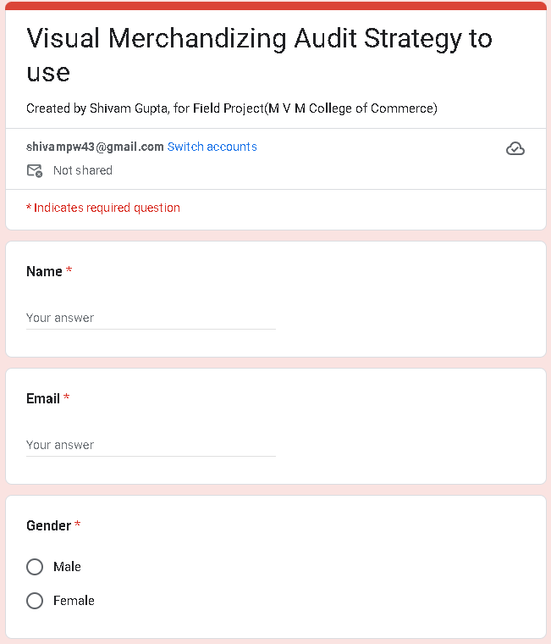

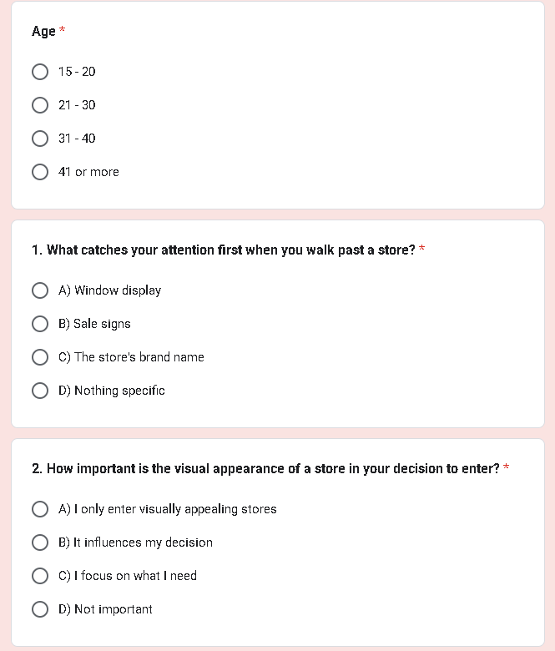

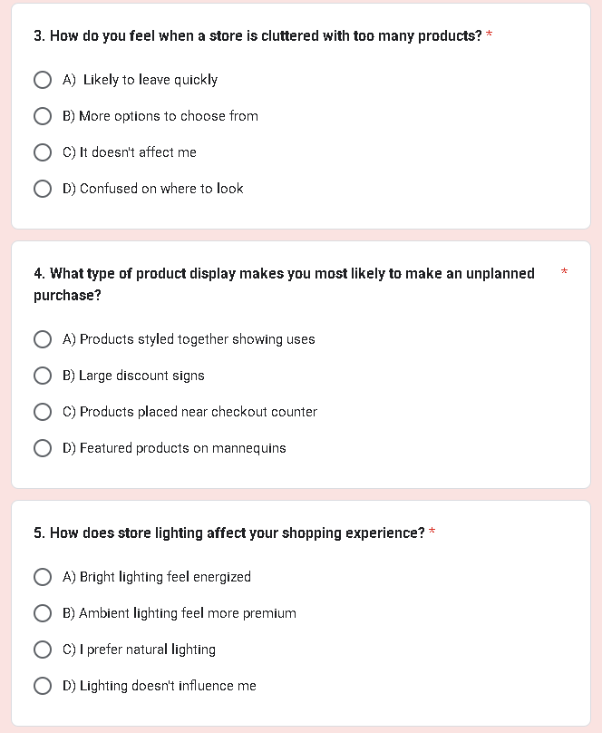

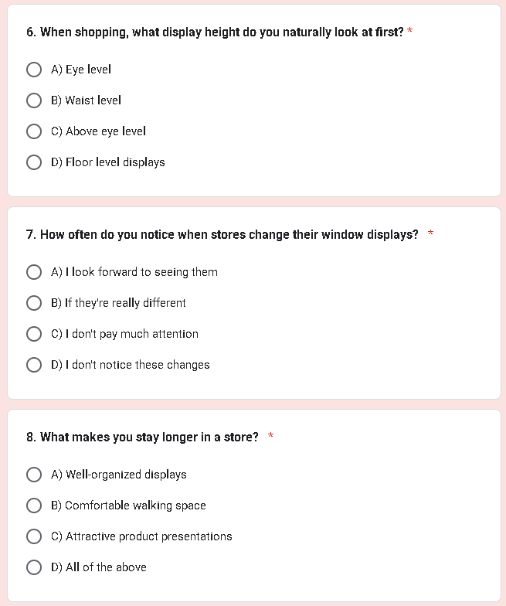

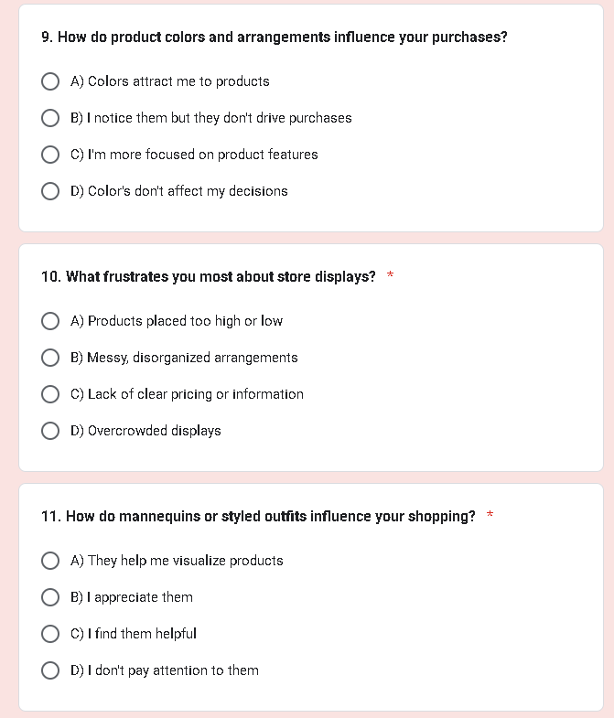

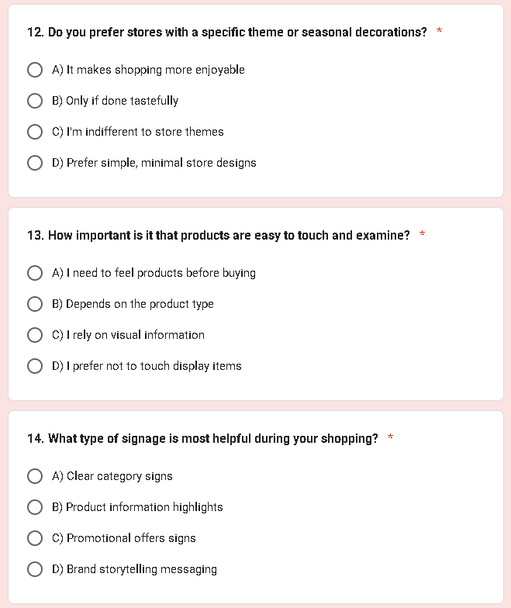

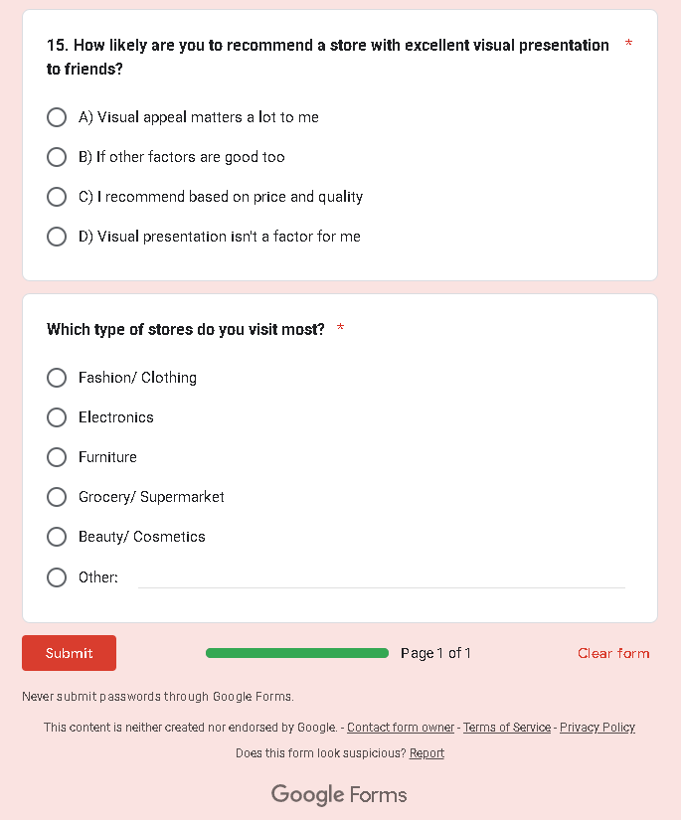

  - Demographic Profile of Respondents Table 5.1: Gender Distribution
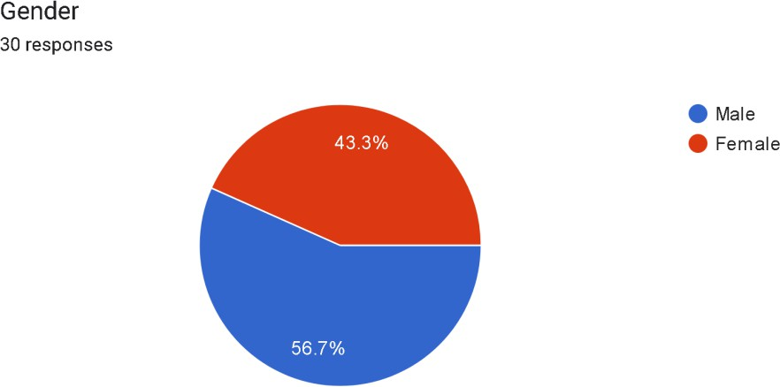
Table 5.2: Age Distribution
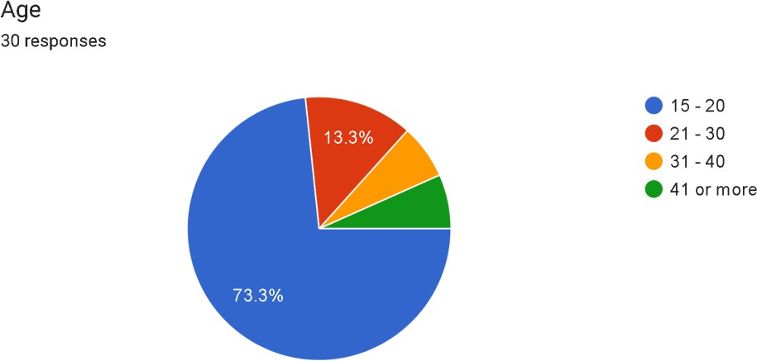

  - Analysis of Visual Elements Attracting Customers Table 5.3: First Element That Catches Attention
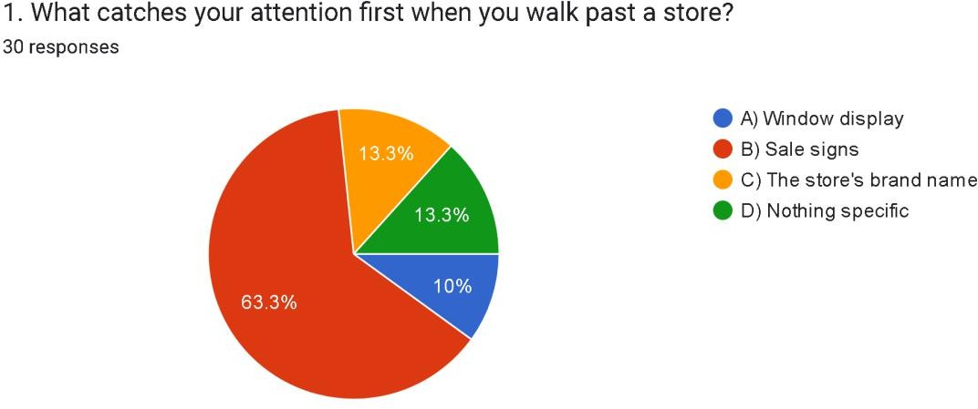
Table 5.4: Importance of Visual Appearance in Store Entry Decision
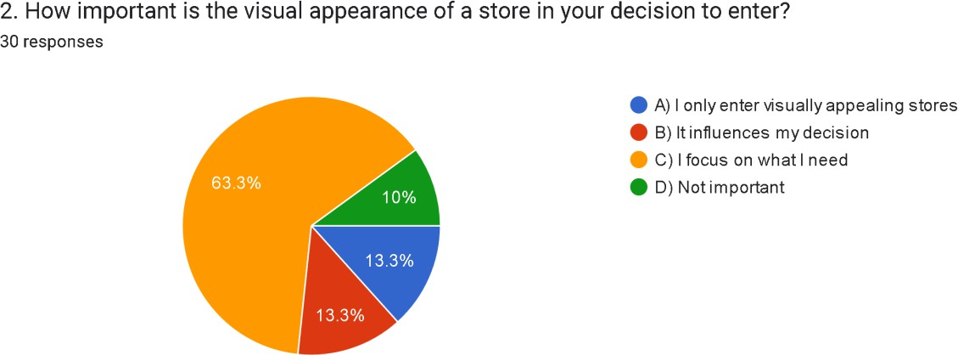

  - Analysis of Store Layout and Organization Preferences

Table 5.5: Response to Cluttered Stores
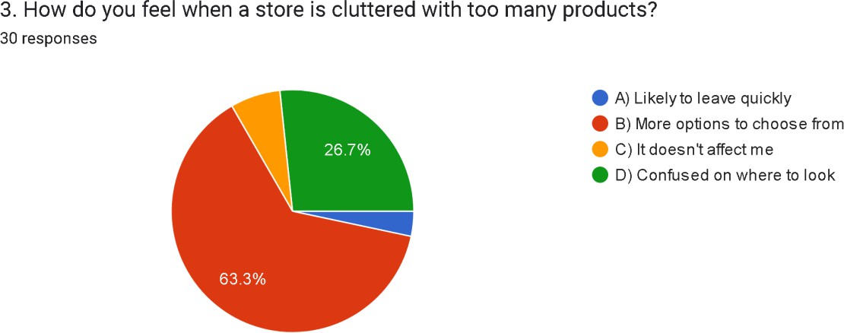
Table 5.6: Factors That Encourage Longer Store Visits
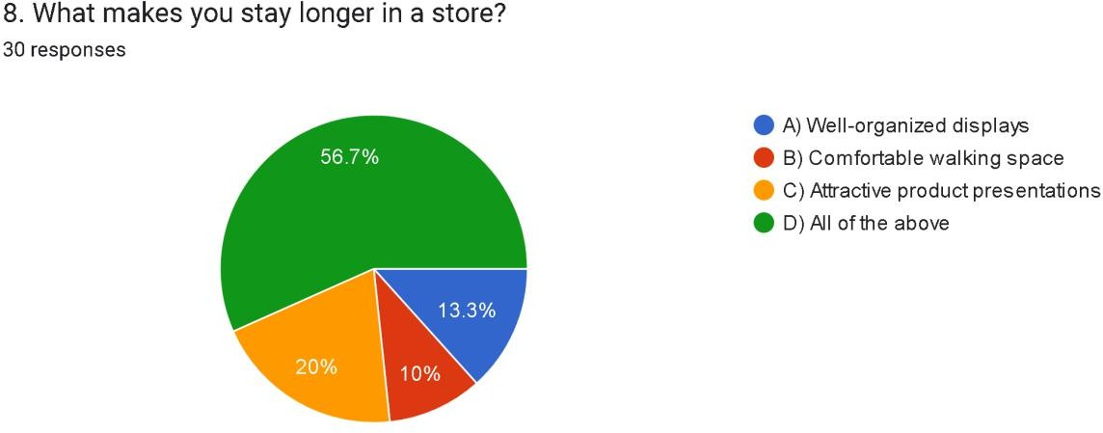

  - Analysis of Purchase Triggers and Display Effectiveness

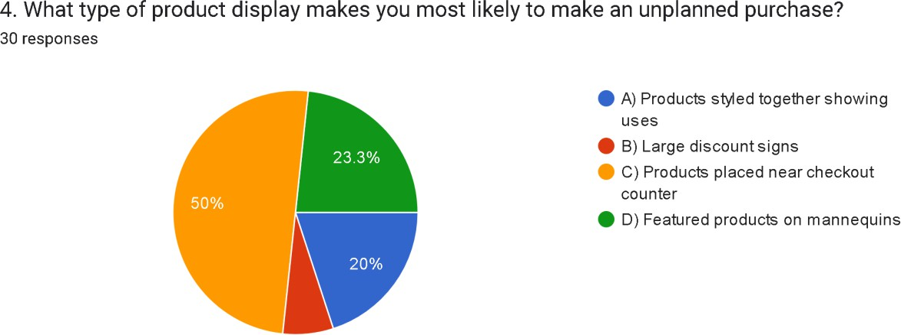
Table 5.7: Display Types That Trigger Unplanned Purchases
Table 5.8: Display Height Naturally Viewed First

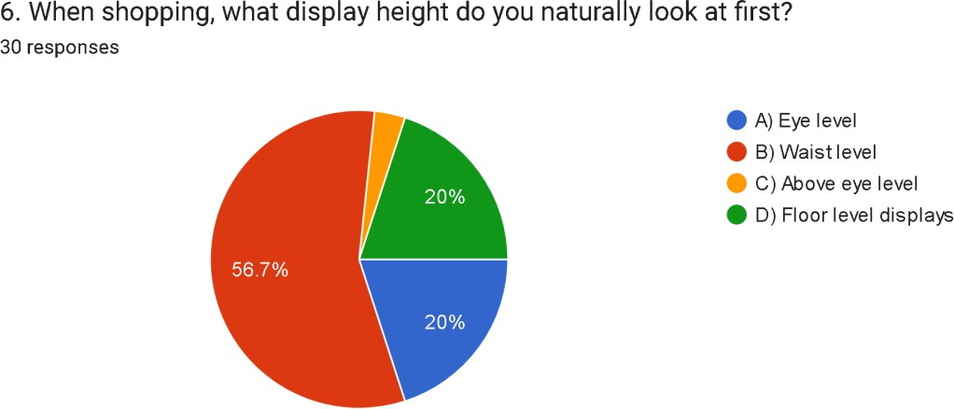

  - Analysis of Lighting, Color, and Thematic Elements Table 5.9: Lighting Preference and Its Impact
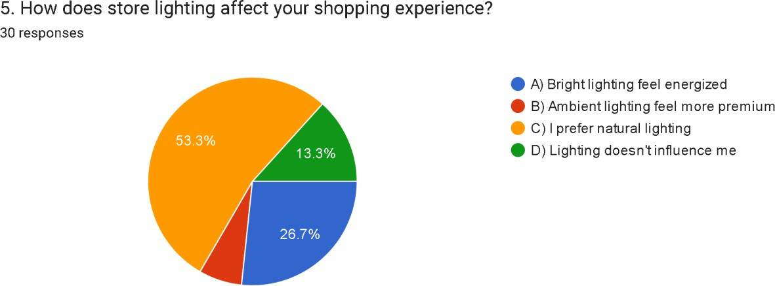
Table 5.10: Influence of Product Colors on Purchases
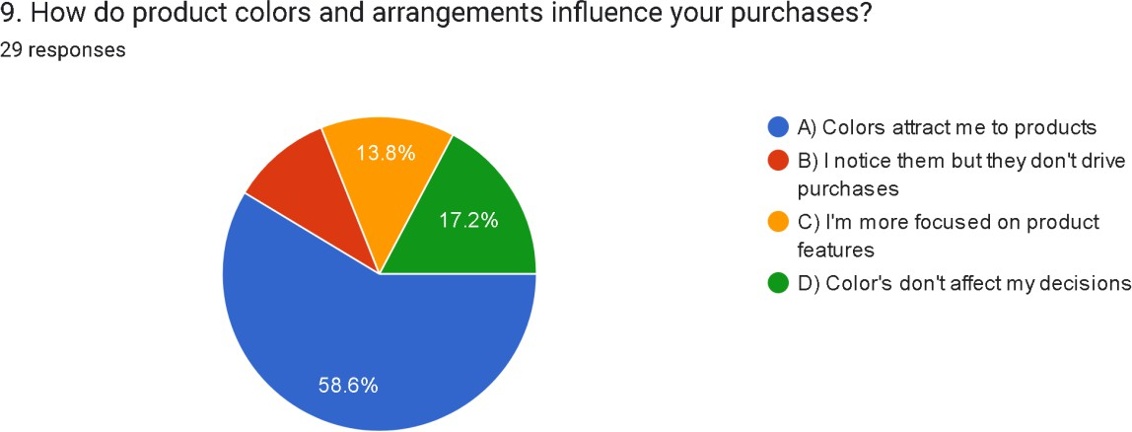

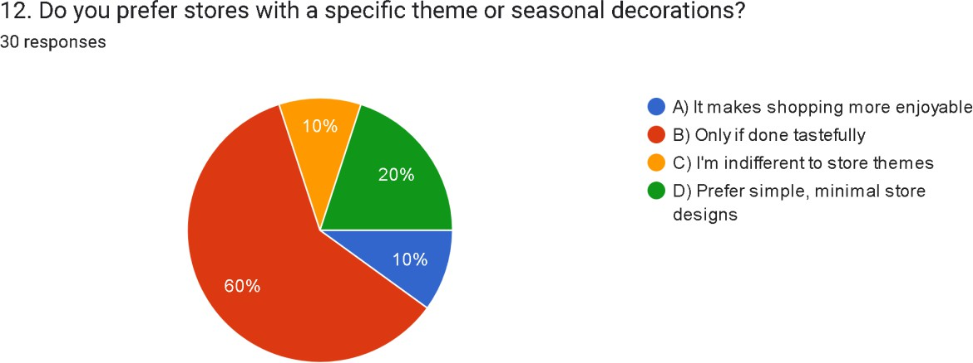
Table 5.11: Preference for Store Themes and Seasonal Decorations

  - Analysis of Customer Pain Points

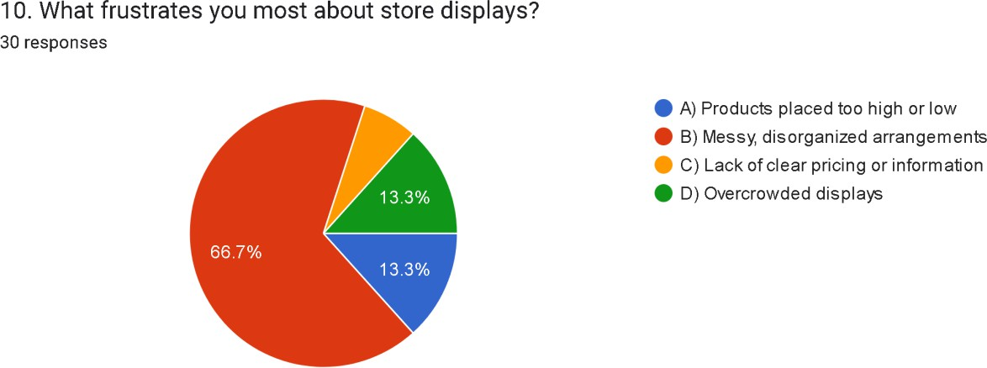
Table 5.12: Most Frustrating Aspects of Store Displays

Table 5.13: Importance of Physical Product Interaction
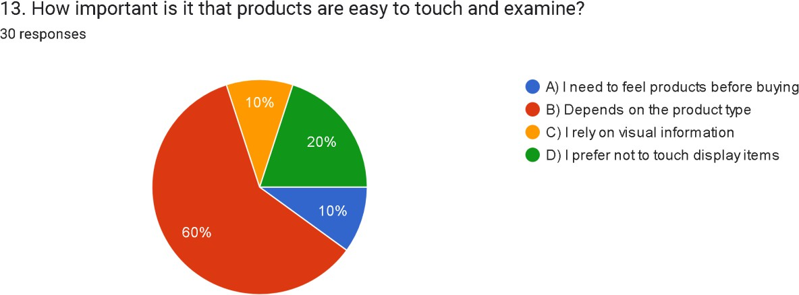
  - Analysis of Signage and Wayfinding Table 5.14: Most Helpful Type of Signage
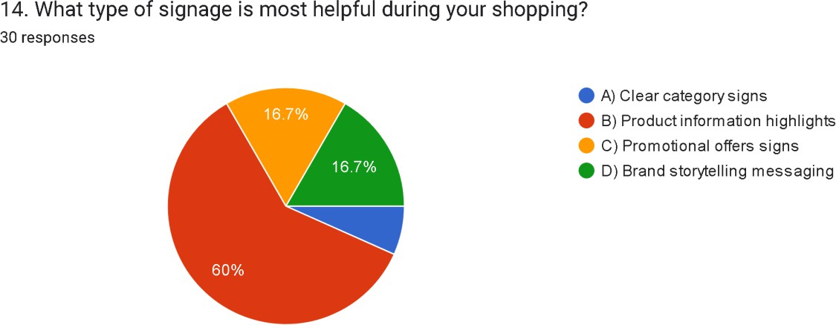

  - Analysis of Mannequins and Window Display Effectiveness

Table 5.15: Frequency of Noticing Window Display Changes
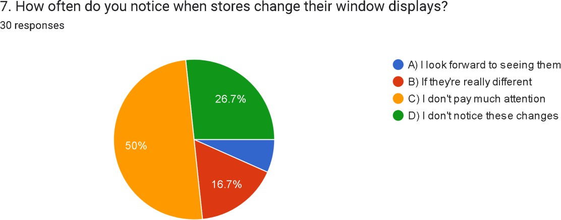
Table 5.16: Influence of Mannequins or Styled Outfits

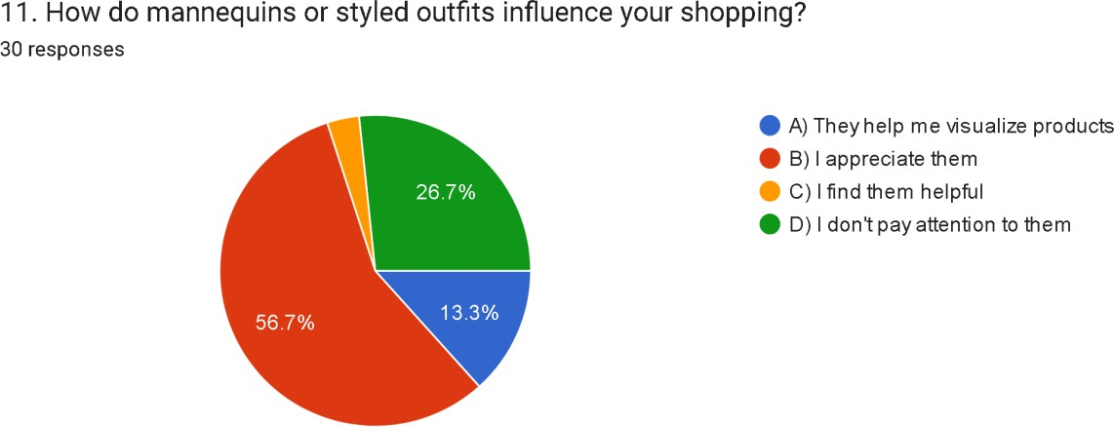

  - Analysis of Recommendation Likelihood

Table 5.17: Likelihood to Recommend Based on Visual Presentation
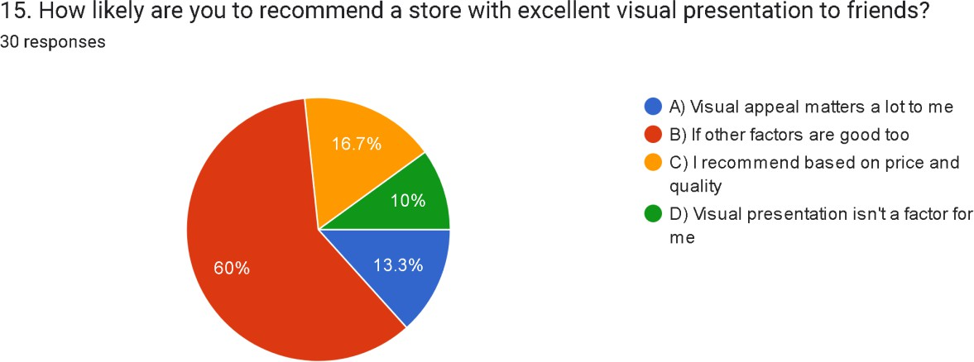

CHAPTER 6: FINDINGS

Based on the data analysis from 31 respondents, the following key findings emerge:

Attention and Attraction

Passive Attention is Low: 13.3% of shoppers don't notice specific visual elements when passing stores, indicating moderate passive attention exists but varies significantly.
Sale Signs Dominate Attention: 60% of respondents are attracted by sale signs, making this the most effective attention-grabber, followed by window displays (13.3%) and brand names (13.3%).
Practicality Dominates: 63.3% of customers prioritize their shopping needs over a store's visual appearance when deciding whether to enter, while 13.3% only enter visually appealing stores.

Store Environment Preferences

Clutter Response is Mixed: 56.7% of customers view cluttered stores positively as providing more options to choose from, while 30% feel confused on where to look and 3.3% are likely to leave quickly. Only 10% remain unaffected.
Holistic Experience Required: 53.3% want well-organized displays, comfortable space, AND attractive presentations—not just one element.
Organization Concerns Dominate: 53.3% cite messy, disorganized arrangements as their biggest frustration, followed by products placed too high or low (20%), overcrowded displays (13.3%), and lack of clear pricing or information (6.7%).

Purchase Behavior Insights

Checkout Placement is Most Effective: 50% identify checkout-area products as most likely to trigger impulse purchases, confirming this strategy's effectiveness.

Waist-Level Advantage: 53.3% naturally look at waist-level displays first, challenging the traditional "eye level is buy level" principle. Only 20% look at eye level first.
Mannequins Have Mixed Impact: 26.7% don't pay attention to mannequins at all, while 50% appreciate them but don't rely heavily on them. Only 13.3% find them helpful for visualization.
Display Variety Influences Purchases: Styled products showing uses (26.7%), large discount signs (6.7%), and featured products on mannequins (16.7%) also drive unplanned purchases.

Sensory Preferences

Natural Lighting Preferred: 50% prefer natural lighting in stores, while 26.7% prefer bright, energizing lighting and only 6.7% associate ambient lighting with premium experiences. 16.7% indicate lighting doesn't influence them.
Color Attracts But Doesn't Always Drive Purchases: 50% are attracted to products by colors, but 23.3% focus more on product features, and 16.7% say colors don't affect their decisions at all.
Tasteful Themes Welcomed: 58.1% appreciate themed displays only if executed tastefully, while 16.1% find them more enjoyable, 12.9% are indifferent, and 12.9% prefer simple, minimal designs.

Physical Interaction

Touch Matters by Category: 53.3% say the importance of touching products depends on product type, with 10% always needing tactile interaction and 13.3% preferring not to touch display items.
Product Information Signage Wins: 53.3% find product information and feature highlights most helpful, followed by promotional offers signs (23.3%) and clear category signs (6.7%). Brand storytelling messaging has 16.7% preference.

Display Change Awareness

Low Attention to Display Changes: 50% don't pay much attention to window display changes, and 26.7% don't notice these changes at all. Only 13.3% notice if displays are really different, and 6.7% look forward to seeing them.

Overall Impact

Visual Merchandising as Supporting Factor: Only 16.1% would recommend a store primarily based on visual presentation. For 56.7%, it matters only if price and quality are also good, positioning visual merchandising as an enhancement rather than a primary competitive advantage.

CHAPTER 7: CONCLUSION & SUGGESTIONS

  - Conclusion

This study reveals important insights about the role and limitations of visual merchandising in contemporary retail environments. While visual merchandising remains a valuable component of the retail experience, its impact is more nuanced than traditional retail wisdom suggests.

Key Conclusions:
- The Sale Sign Supremacy: With 60% of shoppers drawn primarily to sale signs versus only 13.3% to window displays, the data reveals that promotional messaging dramatically outperforms aesthetic merchandising in capturing initial attention. This suggests retailers should prioritize clear value communication over purely decorative displays.
- The Clutter Paradox: Contrary to traditional merchandising wisdom, 56.7% of respondents view clutter positively as providing "more options to choose from." Only 30% feel confused and 3.3% want to leave quickly. This challenges the conventional "less is more" approach and suggests that perceived abundance may create value for certain demographics, particularly younger shoppers who expect variety.

- The Practicality Principle: With 63.3% prioritizing shopping needs over visual appearance, customers remain fundamentally mission-driven. However, 13.3% only enter visually appealing stores, indicating a small but significant segment for whom aesthetics are paramount. Visual merchandising must support practical shopping goals rather than replace them.
- Organization Over Information: The biggest frustration is messy, disorganized arrangements (53.3%), not lack of pricing information (6.7%). This inverts the expected hierarchy and suggests that navigational clarity and visual order matter more than detailed product information for this demographic.
- Checkout Placement Effectiveness Confirmed: With 50% identifying checkout-area products as impulse purchase triggers, this strategic placement proves highly effective. However, the diversity of other triggers (styled products at 26.7%, mannequins at 16.7%) suggests multiple merchandising approaches can work.
- The Waist-Level Revolution: The finding that 53.3% naturally look at waist- level displays first, compared to only 20% at eye level, fundamentally challenges decades of "eye level is buy level" merchandising wisdom. This likely reflects shopping with carts, mobile phone usage, or natural scanning patterns of younger consumers.
- Natural Lighting Preference: The strong preference for natural lighting (50%) over ambient lighting (6.7%) contradicts the assumption that dim, atmospheric lighting creates premium experiences. Younger consumers appear to value authenticity and brightness over manufactured ambiance.
- The Mannequin Ambivalence: With 26.7% ignoring mannequins entirely and only 13.3% finding them helpful for visualization, mannequins show limited effectiveness. However, 50% appreciate them passively, suggesting they contribute to ambiance without driving decisions.
- Color as Attraction, Not Decision Driver: While 50% are attracted to products by colors, 23.3% focus on product features instead, and 16.7% say colors don't affect decisions. This positions color as an attention-getter but not a purchase driver, requiring supplementation with functional information.

- Display Change Blindness: With 76.7% either not paying attention to or not noticing window display changes, frequent refresh cycles may not justify their investment. This challenges the conventional wisdom of regular display rotation.
- Visual Merchandising as Enhancement, Not Driver: Only 16.1% would recommend a store primarily based on visual presentation, while 56.7% require good prices and quality too. This definitively positions visual merchandising as a supporting element rather than a primary competitive advantage.
- The Young Consumer Lens: With 70% of respondents aged 15-20, these findings reflect adolescent and young adult preferences. This demographic values choice abundance, practical functionality, promotional clarity, and natural environments over traditional luxury merchandising cues.

Overall Conclusion:
This research demonstrates that effective visual merchandising for younger consumers must prioritize promotional clarity, navigational simplicity, strategic product placement, and natural store environments over traditional aesthetic merchandising approaches. The most successful approach balances perceived abundance with organizational clarity, uses lighting and color to attract rather than manipulate, and ensures visual elements support rather than overshadow the core shopping mission.
The study confirms that while visual merchandising can attract attention and support purchasing decisions, it works best as part of an integrated retail strategy that prioritizes clear value communication, organized presentation, strategic placement, and meeting customer needs efficiently and transparently.

Chapter 8: Suggestions and Recommendations
Based on the research findings, the following practical recommendations are proposed for retail businesses, merchandising professionals, and store managers:

For Store Layout and Organization
- Balance Abundance with Organization
  - Given that 56.7% appreciate having more options (viewing clutter positively), create generous product assortments
  - However, maintain clear organization to accommodate the 30% who feel confused by clutter
  - Use zoning strategies: high-variety sections for browsers, streamlined sections for mission-driven shoppers
  - Implement clear sightlines and logical product groupings despite higher product density

Optimize Vertical Space Strategically
  - Prioritize waist-level display space given that 53.3% of customers look there first
  - Place high-margin and priority products at waist level (2.5-4 feet)
  - Reserve eye level (20% look there first) for complementary products and promotional signage
  - Use floor-level displays (16.7% look there first) for bulk items and value products
  - Keep top shelves for overflow and backup inventory

Create Clear Navigation Pathways
  - Address the #1 frustration (messy, disorganized arrangements - 53.3%) with clear pathways
  - Design wide aisles that allow comfortable browsing while maintaining product density
  - Use consistent category groupings that make logical sense

  - Implement clear floor markings or carpet runners to guide traffic flow

For Promotional Strategy
- Maximize Sale Signage Visibility
  - Leverage the fact that 60% are attracted by sale signs
  - Position promotional signage at store entrances, windows, and key traffic points
  - Use bold, clear typography that's visible from outside the store
  - Rotate promotional messaging more frequently than aesthetic displays
  - Invest more heavily in sale signage than decorative window displays (which attract only 13.3%)

Implement Value-First Window Displays
  - Since sale signs outperform aesthetic displays 60% to 13.3%, integrate promotional messaging into window displays
  - Lead with price/value propositions rather than pure aesthetics
  - Display bestsellers and sale items prominently in windows
  - Update promotional windows more frequently than seasonal decorative displays

Clarify Pricing Strategy
  - While only 6.7% cited lack of clear pricing as their top frustration, ensure all products are clearly priced
  - Use large, legible price tags
  - Include comparative pricing (was/now, savings percentage) for sale items
  - Consider digital price displays for easy updates

For Product Placement and Displays
- Maximize Checkout Area Merchandising
  - Strategically leverage the 50% who identify checkout areas as impulse purchase triggers

  - Stock small, affordable items with immediate appeal
  - Rotate checkout merchandise weekly to maintain novelty
  - Include complementary items related to common purchases
  - Ensure checkout displays don't create congestion

Diversify Display Strategies
  - Since 26.7% respond to styled products showing uses, create lifestyle vignettes
  - Use mannequins strategically (16.7% effectiveness) for complete outfit inspiration
  - Combine multiple approaches: lifestyle displays, discount signage, and featured products
  - Test which display types work best for specific product categories

Reconsider Mannequin Investment
  - Given that 26.7% don't pay attention to mannequins, evaluate ROI carefully
  - Focus mannequin investments on fashion/clothing stores (46.7% of store visits)
  - If using mannequins, ensure they're dressed in complete, purchasable outfits with clear pricing
  - Position mannequins in high-traffic areas and update styling weekly
  - Consider alternatives like wall displays or digital screens for non-apparel categories

For Lighting and Ambiance
- Prioritize Natural Lighting
  - With 50% preferring natural lighting, maximize windows and skylights
  - Use bright, daylight-mimicking LED fixtures (26.7% prefer bright, energizing lighting)
  - Avoid dim, ambient lighting (only 6.7% prefer this) except for specific premium sections
  - Ensure all products are well-lit and colors are accurately represented

  - Consider hybrid approaches: natural light during day, bright LEDs at night

Apply Color Psychology Strategically
  - Use colors to attract attention (50% are attracted by colors)
  - Ensure color doesn't overshadow product features (23.3% focus on features instead)
  - Create color-coordinated sections for easier navigation
  - Use warm colors for promotional areas and sale sections
  - Maintain product visibility over color scheme aesthetics

Execute Themes Tastefully
  - Honor the 58.1% who want tasteful thematic execution
  - Balance the 16.1% who enjoy themed displays with the 12.9% who prefer minimalism
  - Keep seasonal decorations subtle and supportive of product visibility
  - Avoid overwhelming themes that distract from merchandise
  - Focus themes on major holidays only (Christmas, Diwali, etc.)

For Customer Experience Enhancement
- Enable Category-Appropriate Physical Interaction
  - Recognize that 53.3% need touch based on product type
  - Make tactile products (clothing, fabrics, textiles) highly accessible
  - Provide testers for cosmetics and fragrances
  - Allow electronics to be handled and demonstrated
  - Balance accessibility with security needs
  - Train staff to encourage appropriate product handling

Optimize Signage Strategy
  - Prioritize product information signage (53.3% preference)
  - Create promotional offer signs (23.3% find most helpful)
  - Implement clear category signs (6.7% need this)
  - Use minimal brand storytelling messaging (16.7% preference)

  - Position signage at waist-to-eye level for maximum visibility
  - Keep messaging concise and scannable

Don't Over-Invest in Display Rotation
  - Given that 76.7% don't pay attention to or notice display changes
  - Reduce frequency of window display updates (monthly instead of weekly)
  - Allocate budget to in-store promotional signage instead
  - Focus on major seasonal transitions only
  - Invest saved resources in product assortment and pricing

For Store Type-Specific Strategies
- Fashion/Clothing Stores (46.7% of visits)
  - Emphasize waist-level display of featured items
  - Use mannequins strategically for complete looks
  - Enable physical interaction with all fabrics
  - Create abundant assortment with clear organization
  - Maximize checkout impulse items (accessories, small items)

Grocery/Supermarkets (26.7% of visits)
  - Prioritize clear organization over aesthetic displays
  - Use bright, natural lighting throughout
  - Focus on promotional signage for weekly deals
  - Optimize checkout area for high-margin impulse items
  - Create clear category signage and wayfinding

Electronics Stores (13.3% of visits)
  - Allow extensive product handling and demonstration
  - Use bright lighting to showcase product features
  - Provide detailed product information signage
  - Organize by category with clear navigation
  - Staff demo stations for complex products

For Performance Measurement
- Track Relevant Metrics
  - Measure conversion rates by promotional signage type
  - Monitor sales lift from checkout area merchandise
  - Track waist-level vs. eye-level product performance
  - Analyze basket size correlation with merchandising changes
  - Survey customer satisfaction with store organization specifically
  - Test lighting changes and measure dwell time/sales impact

Test and Iterate
  - A/B test promotional signage effectiveness
  - Experiment with product density levels (abundance vs. minimalism)
  - Test different checkout area merchandise categories
  - Trial various lighting schemes and measure response
  - Pilot themed vs. minimal design approaches
  - Gather continuous customer feedback on navigation and organization

For Demographic Considerations
- Tailor to Young Consumer Preferences
  - Recognize that 70% of your respondents (and likely customers) are aged 15- 20
  - Prioritize value communication and promotional clarity
  - Create Instagram-worthy moments without sacrificing functionality
  - Use natural, bright lighting that photographs well
  - Maintain abundant product selection this demographic expects
  - Balance trending aesthetics with practical navigation

Value-Conscious Merchandising
  - Lead with price and value propositions
  - Make sale items highly visible throughout the store
  - Use clear savings messaging ("Save 40%" vs. just showing prices)

  - Position value items prominently, not just premium products
  - Create "price zone" sections for budget-conscious shoppers

CHAPTER 9: REFERENCES / BIBLIOGRAPHY
Books
- Bailey, S., & Baker, J. (2014). Visual Merchandising for Fashion.
Bloomsbury Publishing.
- Bell, J., & Ternus, K. (2017). Silent Selling: Best Practices and Effective Strategies in Visual Merchandising (5th ed.). Fairchild Books.
- Diamond, J., & Diamond, E. (2016). Contemporary Visual Merchandising and Environmental Design (6th ed.). Pearson.
- Morgan, T. (2016). Visual Merchandising: Windows and In-Store Displays for Retail (2nd ed.). Laurence King Publishing.
- Pegler, M. M. (2018). Visual Merchandising and Display (7th ed.). Fairchild Books.
- Underhill, P. (2009). Why We Buy: The Science of Shopping—Updated and Revised for the Internet, the Global Consumer, and Beyond. Simon & Schuster.

Journal Articles
- Cant, M. C., & Hefer, Y. (2014). "Visual merchandising displays effect on consumers: A valuable asset or an unnecessary burden for apparel retailers." International Business & Economics Research Journal, 13(6), 1217-1224.
- Ebster, C., & Garaus, M. (2015). "Store design and visual merchandising: Creating store space that encourages buying." Journal of Retailing and Consumer Services, 22, 23-31.
- Kerfoot, S., Davies, B., & Ward, P. (2003). "Visual merchandising and the creation of discernible retail brands." International Journal of Retail & Distribution Management, 31(3), 143-152.
- Mehrabian, A., & Russell, J. A. (1974). "An approach to environmental psychology." MIT Press, Cambridge, MA.
- Quartier, K., Vanrie, J., & Van Cleempoel, K. (2014). "As real as it gets: What role does lighting have on consumer's perception of atmosphere, emotions and behavior?" Journal of Environmental Psychology, 39, 32-39.

Research Papers and Theses
- Kumar, A., & Kim, Y. K. (2014). "The store-as-a-brand strategy: The effect of store environment on customer responses." Journal of Retailing and Consumer Services, 21(5), 685-695.
- Sadachar, A., Feng, F., Karpova, E. E., & Manchiraju, S. (2016). "Predicting satisfaction with apparel shopping on social networking sites: The role of quality of site and perceived benefits." The International Review of Retail, Distribution and Consumer Research, 26(4), 378-395.

Online Resources and Articles
- Bhasin, H. (2019). "Visual Merchandising – Definition, Elements, Objectives and Importance." Marketing91. Retrieved from https://www.marketing91.com/visual-merchandising/
- Retail Council of Canada. (2020). "Best Practices in Visual Merchandising."
Retail Industry Resources. Retrieved from https://www.retailcouncil.org/

Industry Reports
- Deloitte. (2023). Global Powers of Retailing 2023: Resilience Despite Challenges. Deloitte Touche Tohmatsu Limited.
- Nielsen. (2022). Understanding Point of Purchase Marketing Effectiveness.
Nielsen Holdings.
- PwC. (2023). India Retail Report 2023: The Indian Retail Market.
PricewaterhouseCoopers.

Conference Proceedings
- Jain, V., & Sharma, A. (2017). "Impact of visual merchandising on consumer behavior towards women's apparel." International Conference on Business and Management, Mumbai, India.
- Mehta, N. P., & Chugan, P. K. (2013). "Visual merchandising and its effect on consumer buying behavior." International Conference on Technology and Business Management, Dubai, UAE.

Government Publications
- Ministry of Commerce and Industry, Government of India. (2023). Annual Report 2022-23: Department for Promotion of Industry and Internal Trade.

Websites
- National Retail Federation (NRF). (2023). "Retail Industry Research and Statistics." Retrieved from https://nrf.com/research
- Retail Design Institute. (2023). "Visual Merchandising Guidelines and Standards." Retrieved from https://www.retaildesigninstitute.org/
- WGSN. (2023). "Retail Design and Visual Merchandising Trends." Retrieved from https://www.wgsn.com/

Additional References
- Bitner, M. J. (1992). "Servicescapes: The impact of physical surroundings on customers and employees." Journal of Marketing, 56(2), 57-71.
- Donovan, R. J., & Rossiter, J. R. (1982). "Store atmosphere: An environmental psychology approach." Journal of Retailing, 58(1), 34-57.
- Hussain, R., & Ali, M. (2015). "Effect of store atmosphere on consumer purchase intention." International Journal of Marketing Studies, 7(2), 35-43.
- Kotler, P. (1973). "Atmospherics as a marketing tool." Journal of Retailing, 49(4), 48-64.
- Law, D., Wong, C., & Yip, J. (2012). "How does visual merchandising affect consumer affective response?" European Journal of Marketing, 46(1/2), 112- 133.
- Sen, S., Block, L. G., & Chandran, S. (2002). "Window displays and consumer shopping decisions." Journal of Retailing and Consumer Services, 9(5), 277-290.

